READ ME

USGS Disclaimers

References to non-USGS products and services are provided for information only and do not constitute endorsement or warranty, express or implied, by the USGS, USDOI, or U.S. Government, as to their suitability, content, usefulness, functioning, completeness, or accuracy.

The furnished computer programs and scripts are accepted and used by the recipient individual or group entity with the express understanding that the United States Government makes no warranties, expressed of implied, concerning the accuracy, completeness, reliability, usability, or suitability for any particular purpose of the information or data contained in the programs, or furnished in to any such individual or group entity by reason of use thereof.
INSTALLATION INSTRUCTIONS
If you are concerned you may not have the most recent version of the tool, please visit http://geography.wr.usgs.gov/science/dasymetric/data.htm to download it (free, no registration).
The latest version of the tool is for ArcGIS 10.2, but works on older versions of ArcGIS i.e. ArcMap 9.3. To install this software you must have Admin rights on the computer and ArcGIS must already be installed with the Spatial Analyst extension turned on.
On the web page, click on the link “Zip file containing Daysmetric Mapping Toolbox that can be added to ArcGIS 10.x” The actual name of the file is ‘DasyTool2014.zip’. Unzip the DasyTool2014.zip file by double clicking and using WinZip (or any other unzip software) to Extract the files and save them to the folder destination of your choice.
Files in Zip should include:

- dasyLib.py
- Dasy2014.tbx
- Dasy2014.py
(Save these files to a blank directory dedicated to the new tool)

After extracting the files from the zipped version, go to the folder you designated. You will see:
- A folder named ‘DasyTool2014’
  - Inside the ‘DasyTool2014’ folder there is a file ‘Dasy.tbx’ and another folder named ‘Scripts’
  - Inside the ‘Scripts’ folder there are two Python Files named:
    - Dasy2014.py
    - dasyLib.py

ADDING DASYMETRIC MAPPING TOOLBOX TO YOUR ARCMAP10x DOCUMENT:
- Open a blank map in ArcMap 10x.
- Open ArcToolbox
  - Right Click on ArcToolbox and select Add Toolbox
  - Navigate to where you saved the DasyTool2014 folder
    - Select Dasy2014.tbx (should have red toolbox icon next to it)
    - Tool will automatically be added to your list of Toolboxes
      - Default name is ‘Dasy2014’
      - Expand ‘Dasy2014’ and you will find the actual tool named ‘Dasymetric Mapping 2014’
    - Double Click on ‘Dasymetric Mapping 2014’ and the user interface will come up. Instructions on the tool’s functionality are written in the Tool Help which appears on the right column of the interface. By Clicking on each box, the Tool Help explains each function.

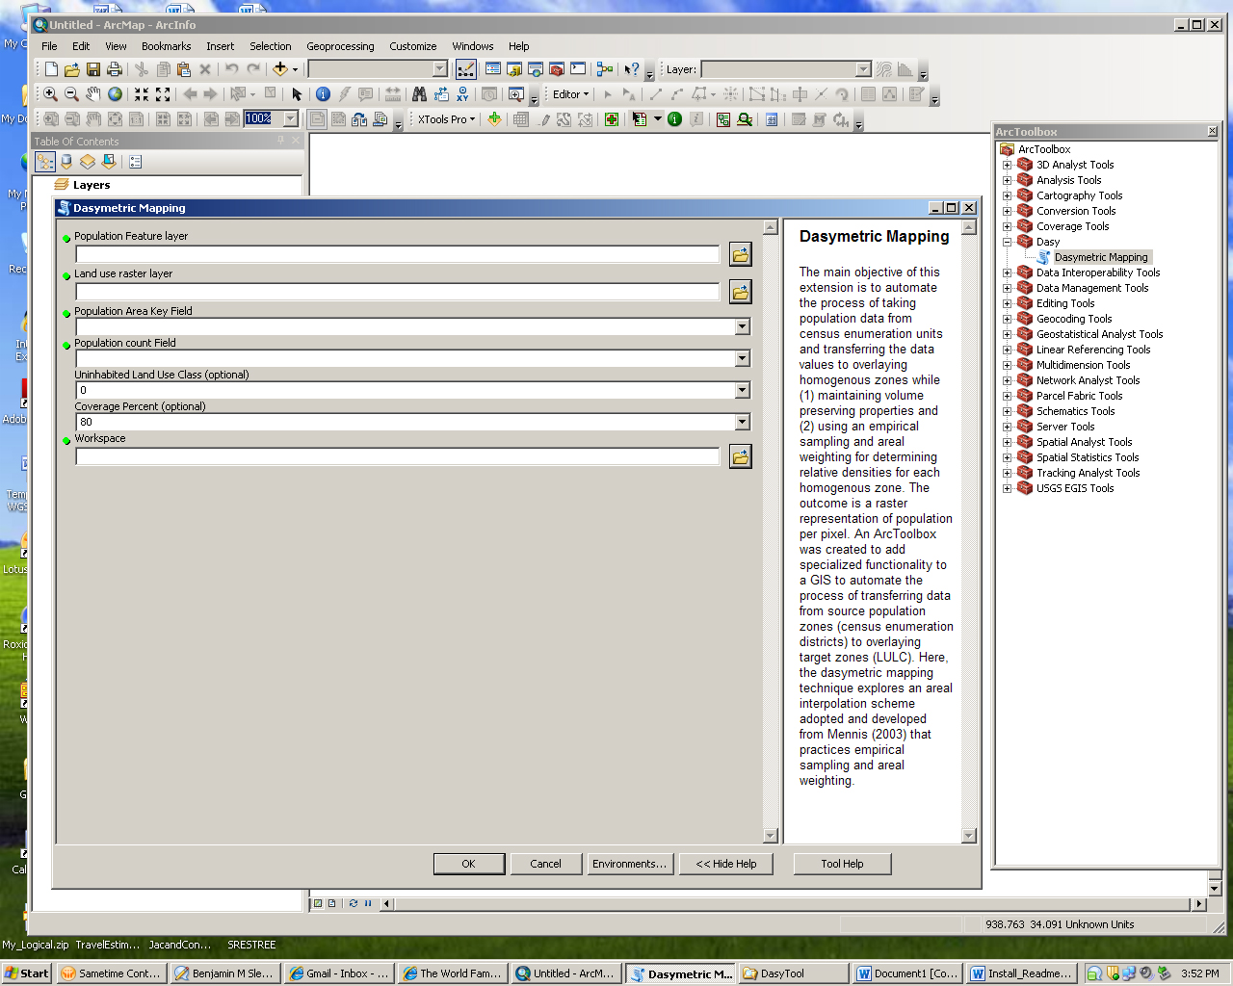

ADDITIONAL RECOMENDATIONS TO CONSIDER:

- Make sure your input datasets are all using the same coordinate and projection information
- Tool runs more efficiently with ArcGRID files
- Your Ancillary Raster Land Use file should be in a thematic format, NOT continuous.

Further Questions Please Contact:
Mike Gould – USGS
mgould@usgs.gov
    - -- or --

Rachel Sleeter - USGS
rsleeter@usgs.gov
253-313-3310

